**Restaurant Menu Management System**

Submitted By: ………………………………………

**Index**

1. Introduction

2. System Specifications

3. Database Design

4. Modules

5. Source Code

6. Output

7. Conclusion

8. Bibliography

**1. Introduction**

This software is designed to provide a digital alternative of displaying menus in a restaurant. The purpose of this project is to develop a menu management system which can be used by restaurant to upload food items to the application to develop their own customized menus which can be accessed digitally by customers.

This project consists of a database with a collection of specifications of a certain food item entered by the user. The design of the application is user friendly and is a convenient tool for creating restaurant menus.

During coding and design, Django which is a high-level Python web framework is used to develop the web application.

**2. System Specifications**

***2.1 Hardware:***

* **CPU:** Intel® Core™ i5-10400T @ 2.00GHz
* **Memory:** 8.0 GB
* **GPU:** Intel® UHD Graphics 630

***2.2 Software:***

* **OS:** Windows® 10
* **Development tools:** Python & Django, designed using VS Code

**3. Database Design**

***3.1 Database Information***

An important aspect of the project is the design of the data storage structure. A SQLITE3 file is the storage container.

***3.2 Design***

The Structure is as follows:

File: db.sqlite3 [Information about food Items]

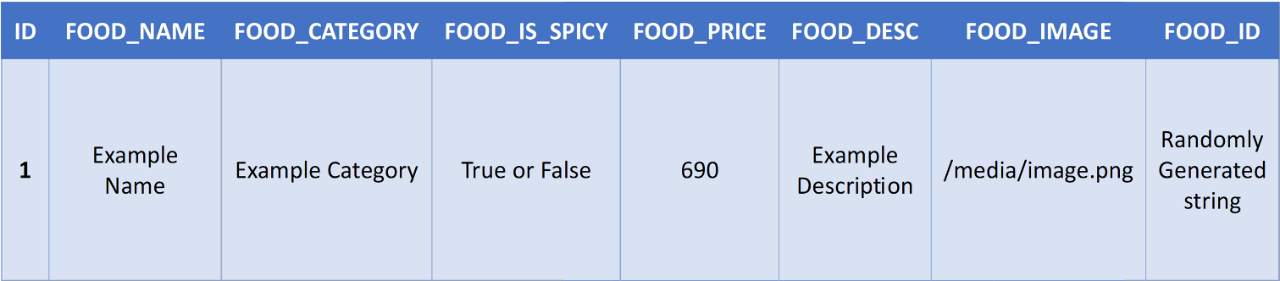

***3.3 Menu Design***

|  |  |  |
| --- | --- | --- |
| Sr. No. | Menu Option | Purpose of Menu Item |
| 1. | Add Food | Upload food item to menu |
| 2. | Add Food Record |  |
| 3. | Manage Food |  |
| 4. | Remove Food | Remove food item off the menu |
| 5. | Edit Food |  |
| 6. | Edit Food Record |  |

**4. Modules**

***4.1 In-Built Functions***

***4.2 User Defined Functions***

**5. Source Code**

The project for Restaurant Menu Management System contains programming codes across various files

File: asgi.py

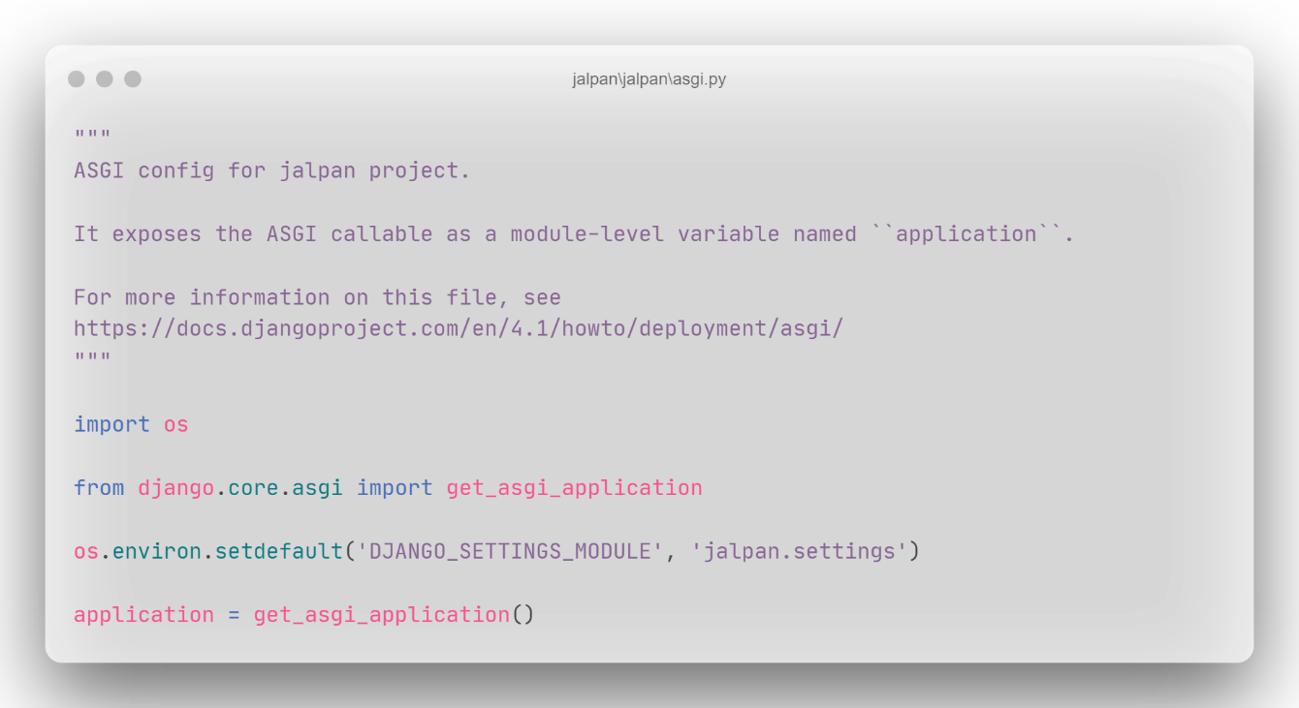

File: setting.py

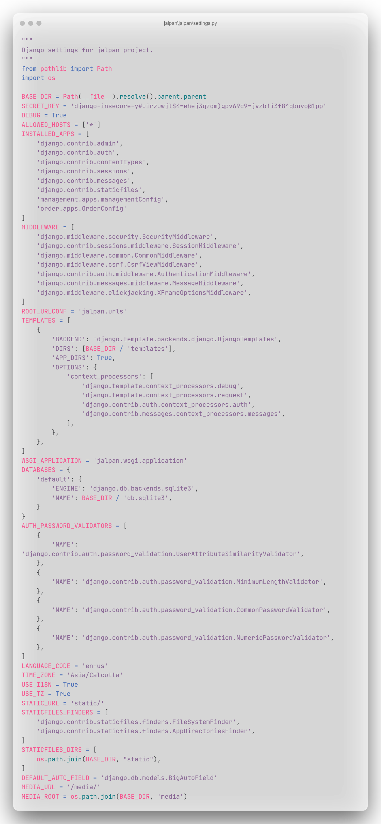

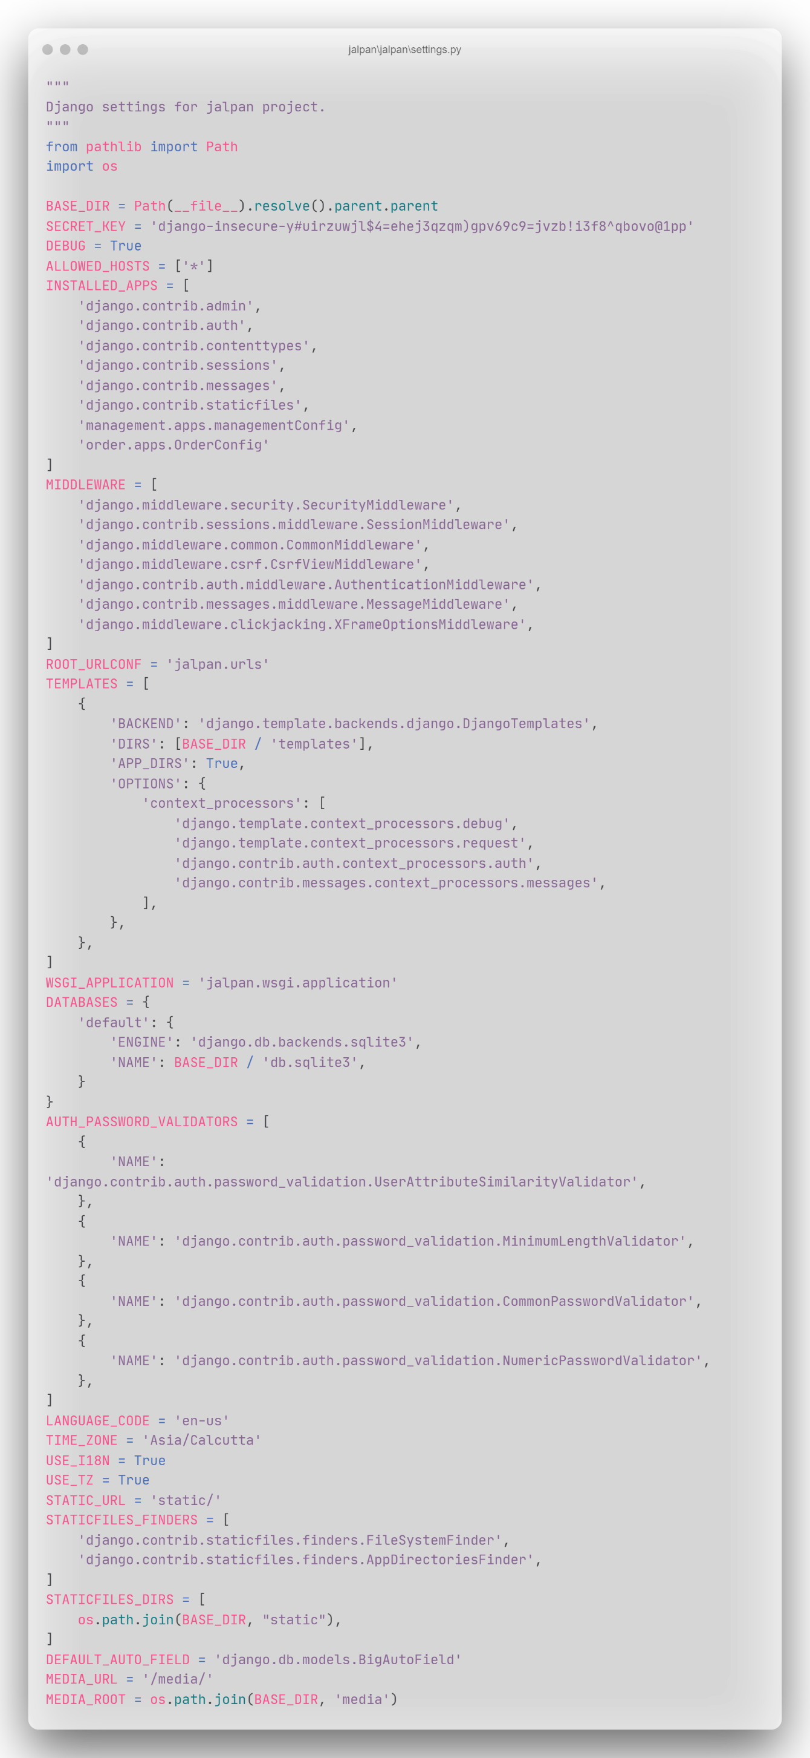

File: urls.py(jalpan)

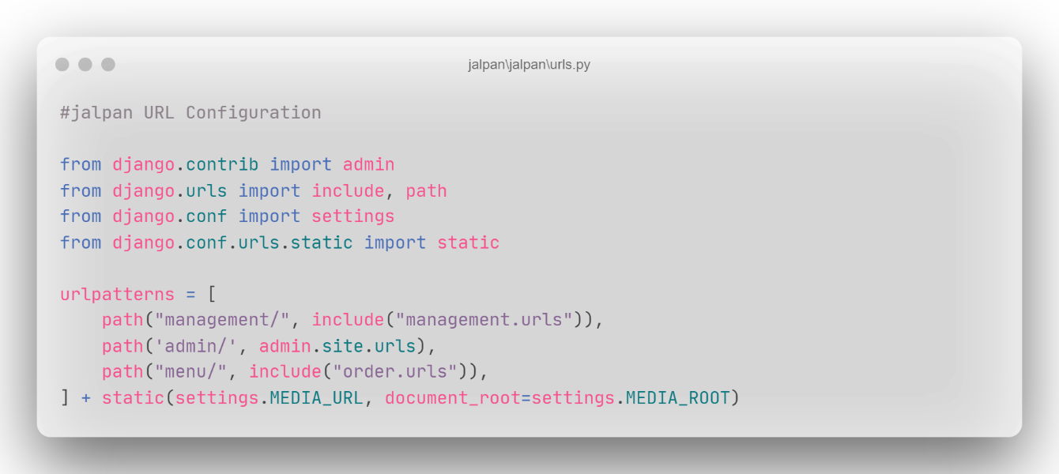

File: wsgi.py

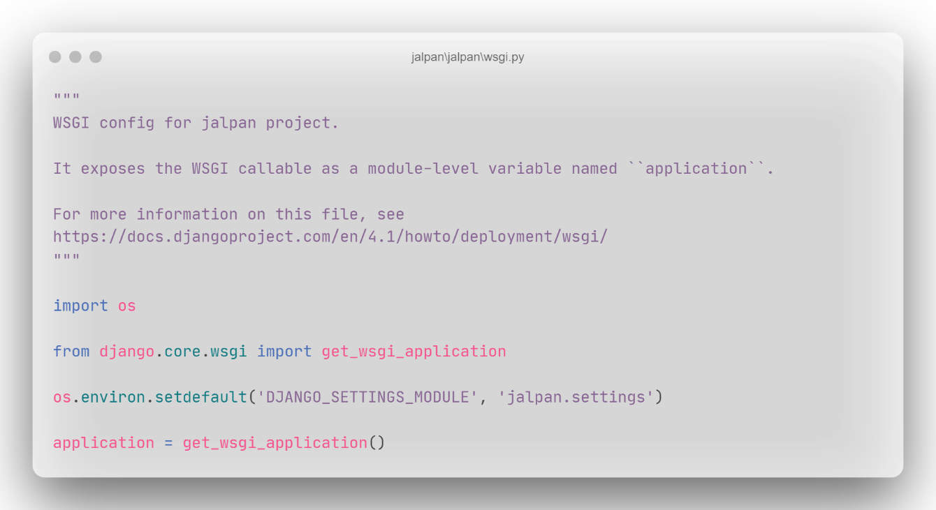

File: admin.py

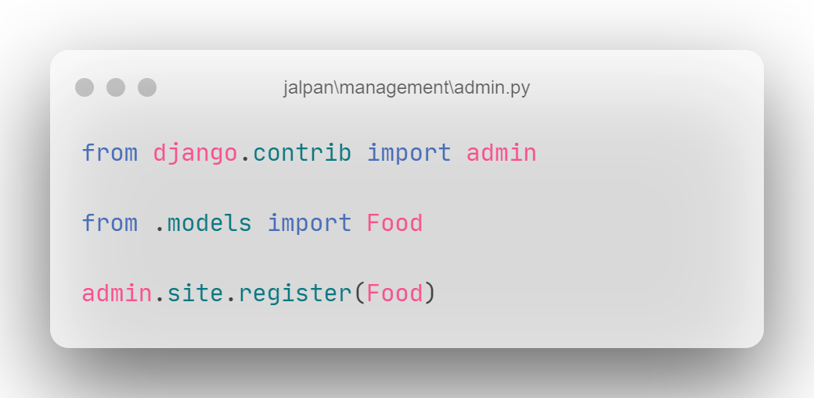

File: apps.py

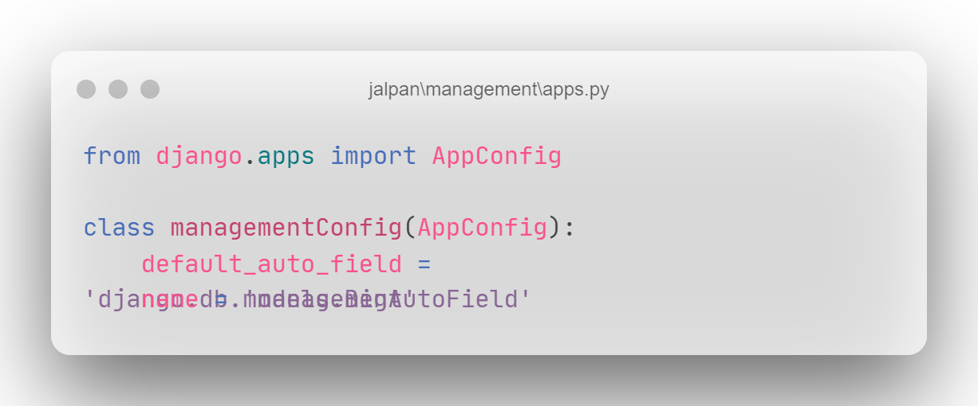

File: models.py

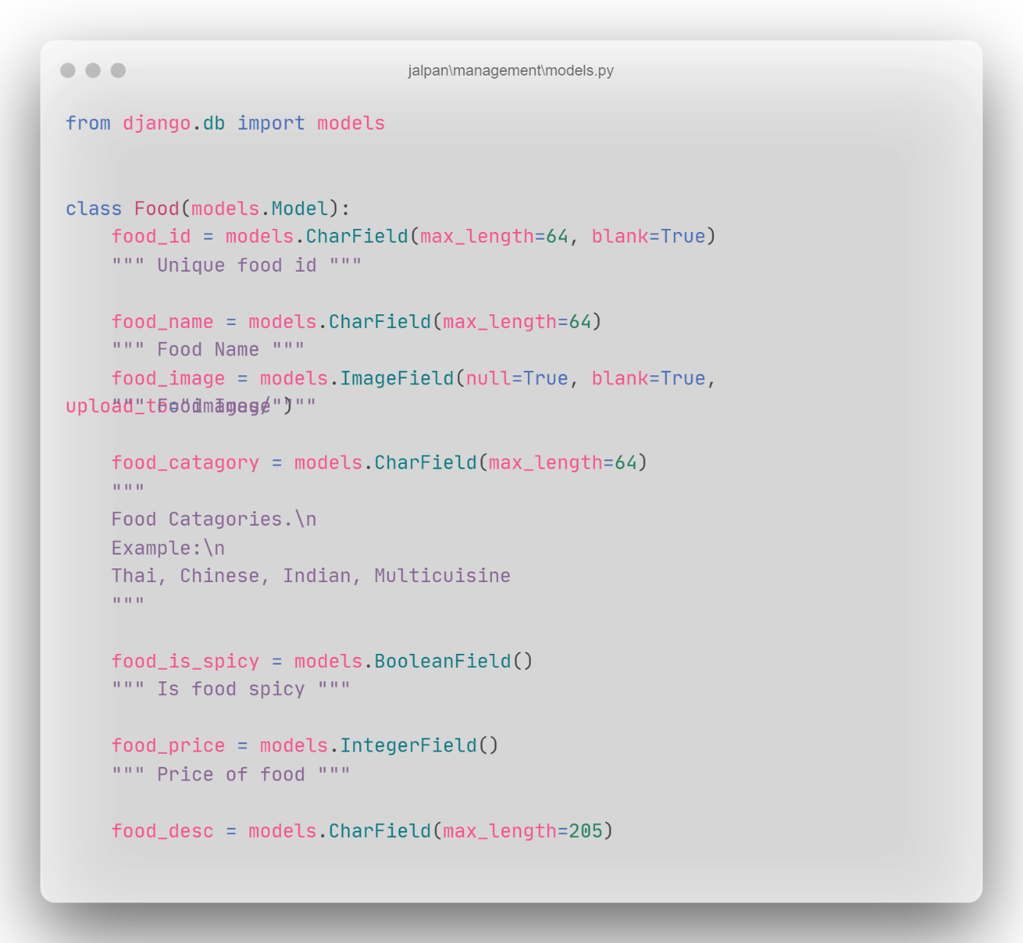

File: addFood.html

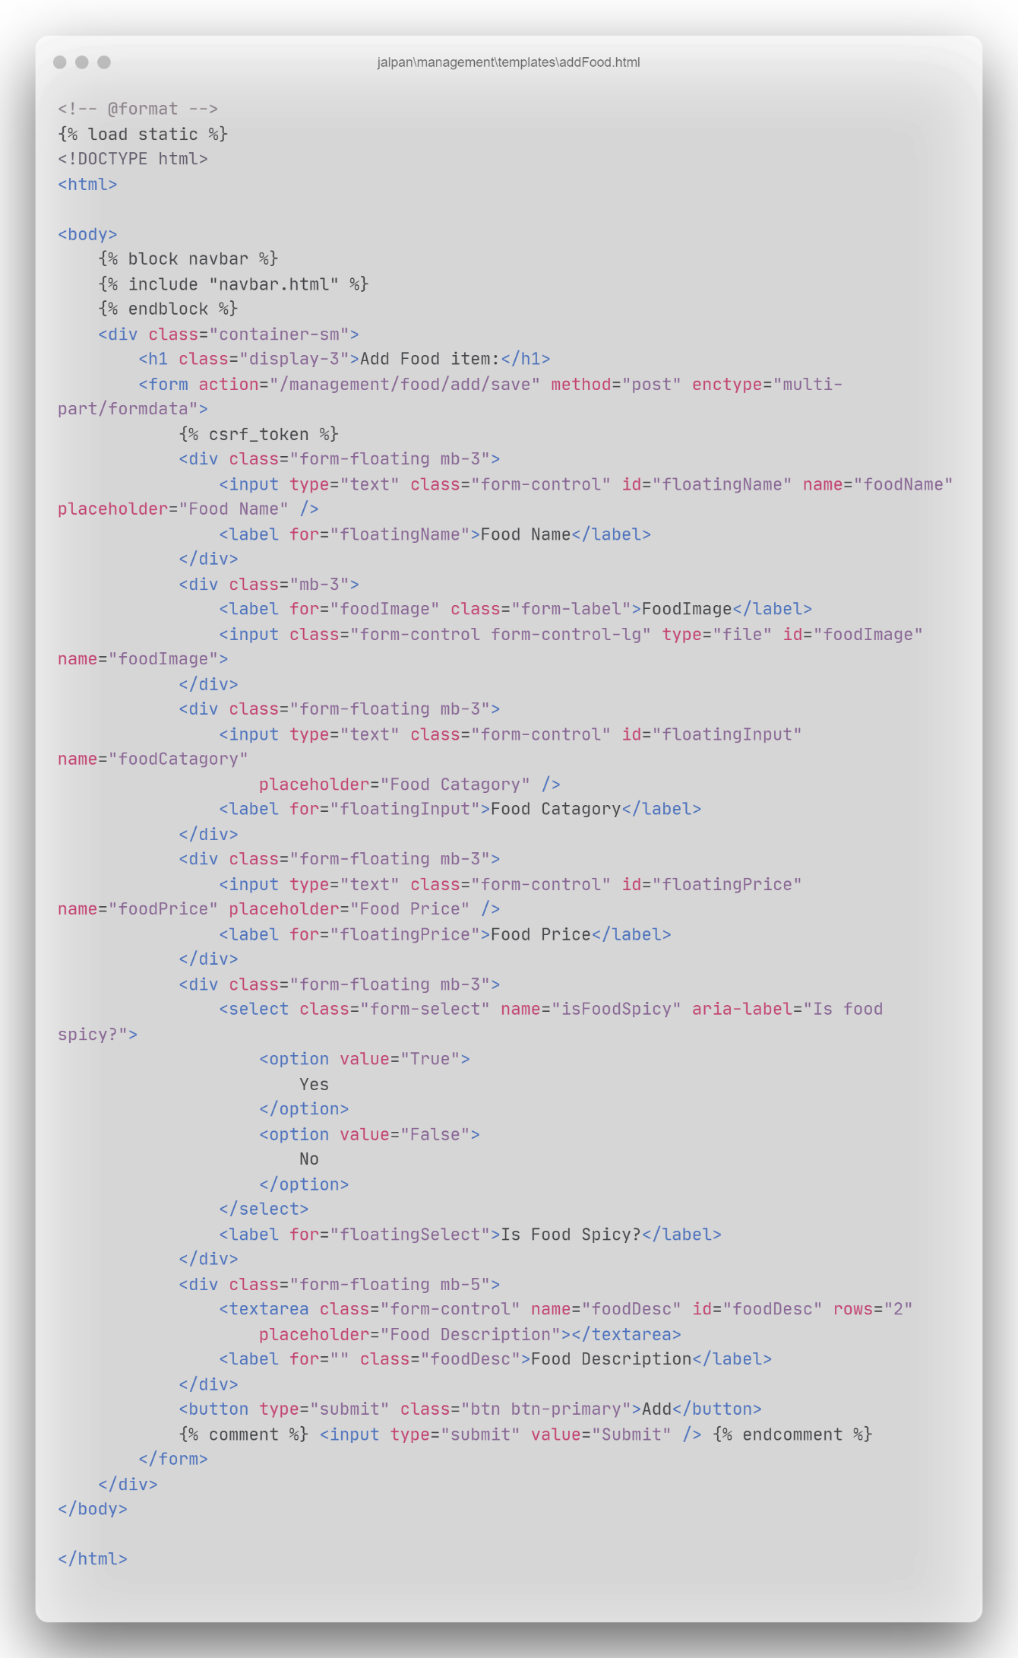

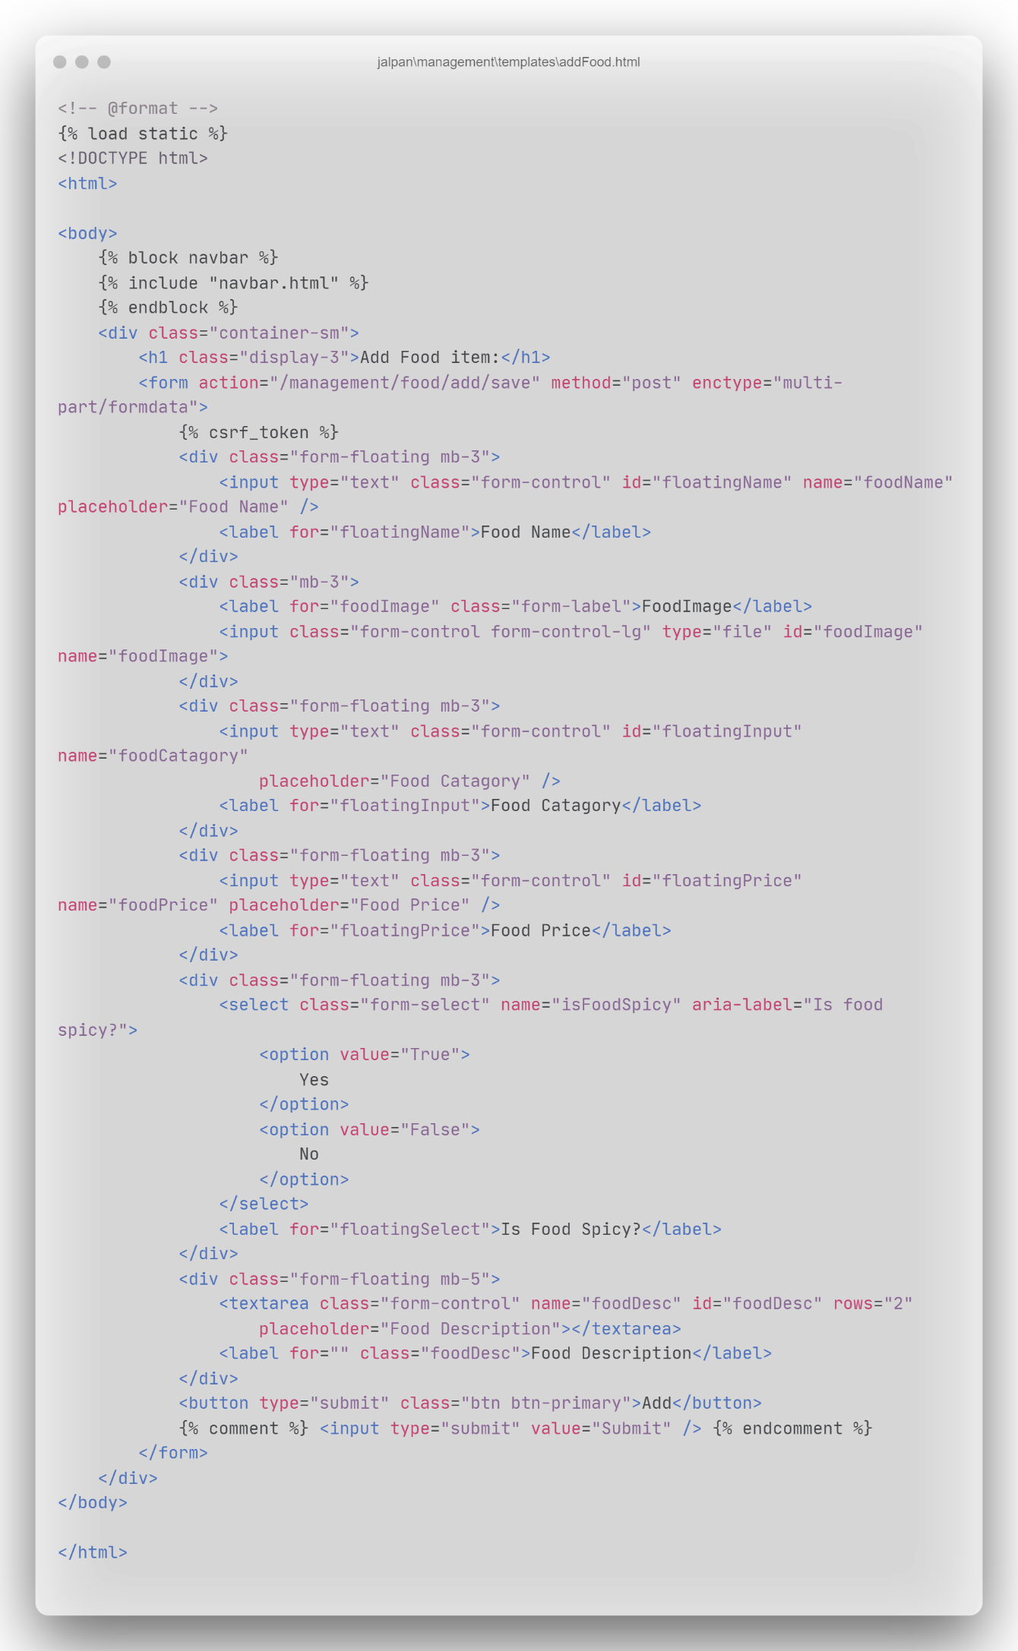

File: editFood.html

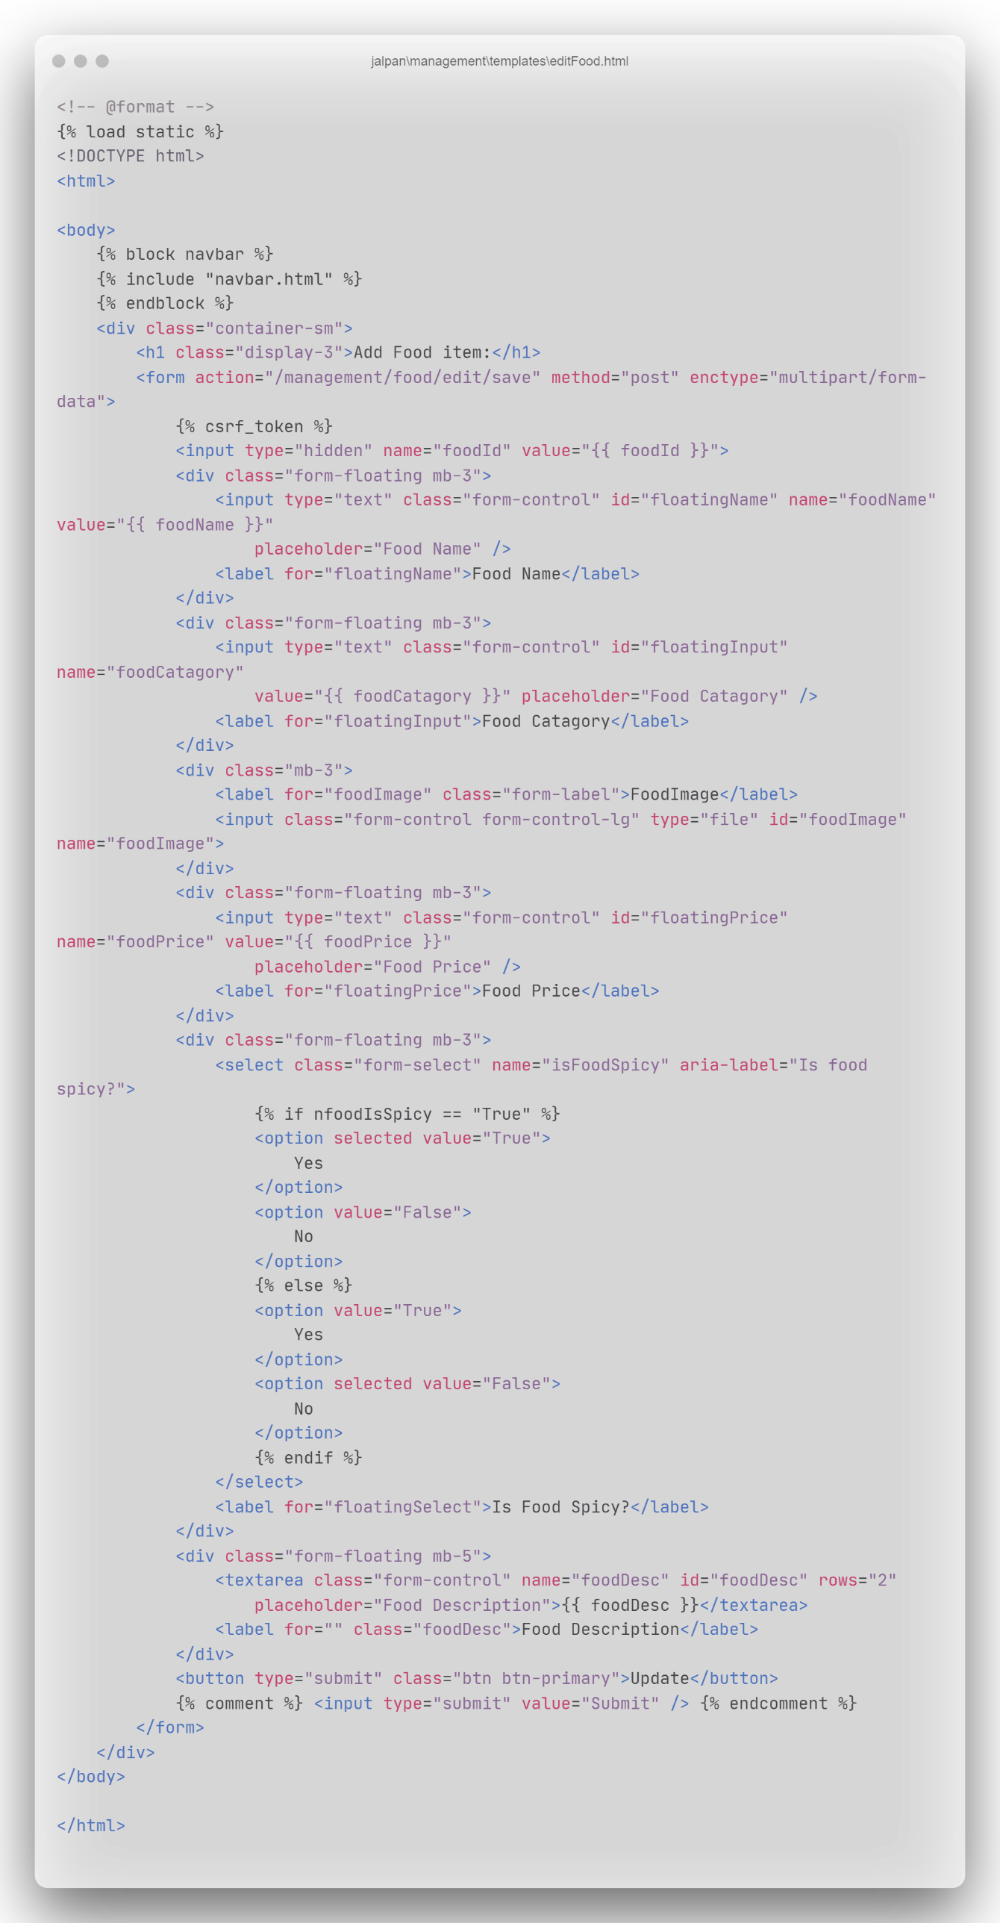

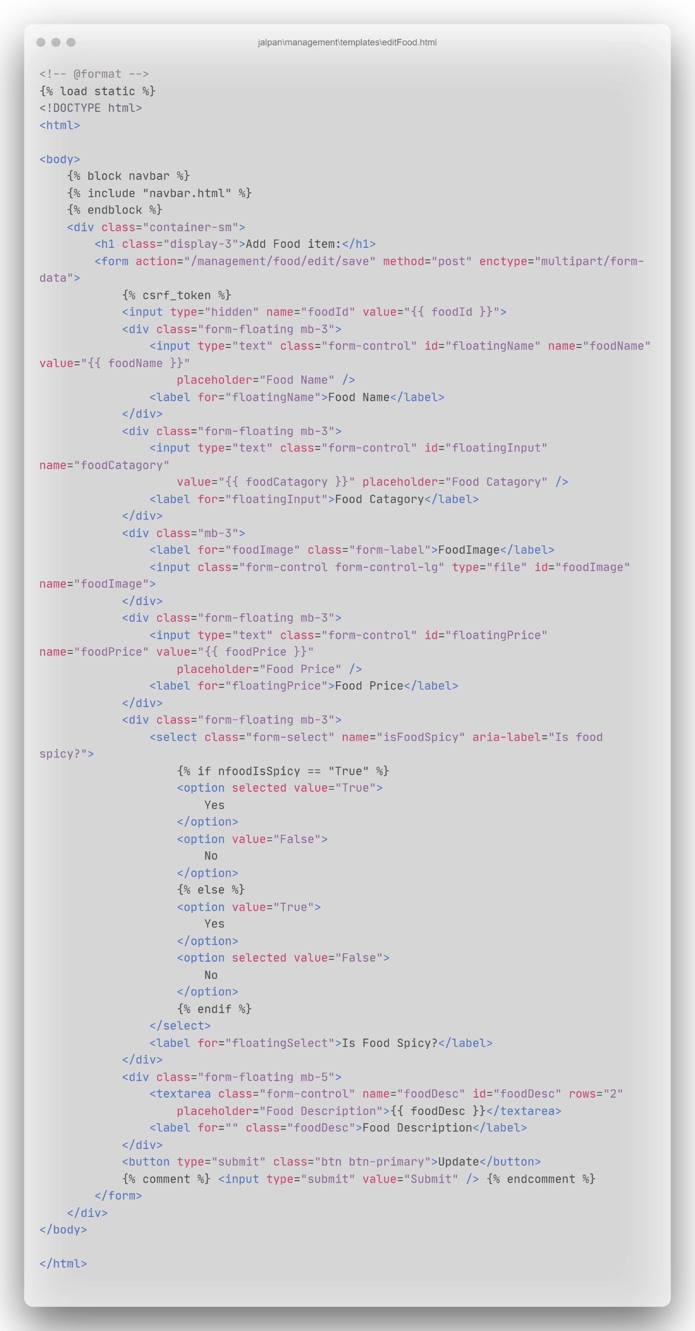

File: editablemenu.html

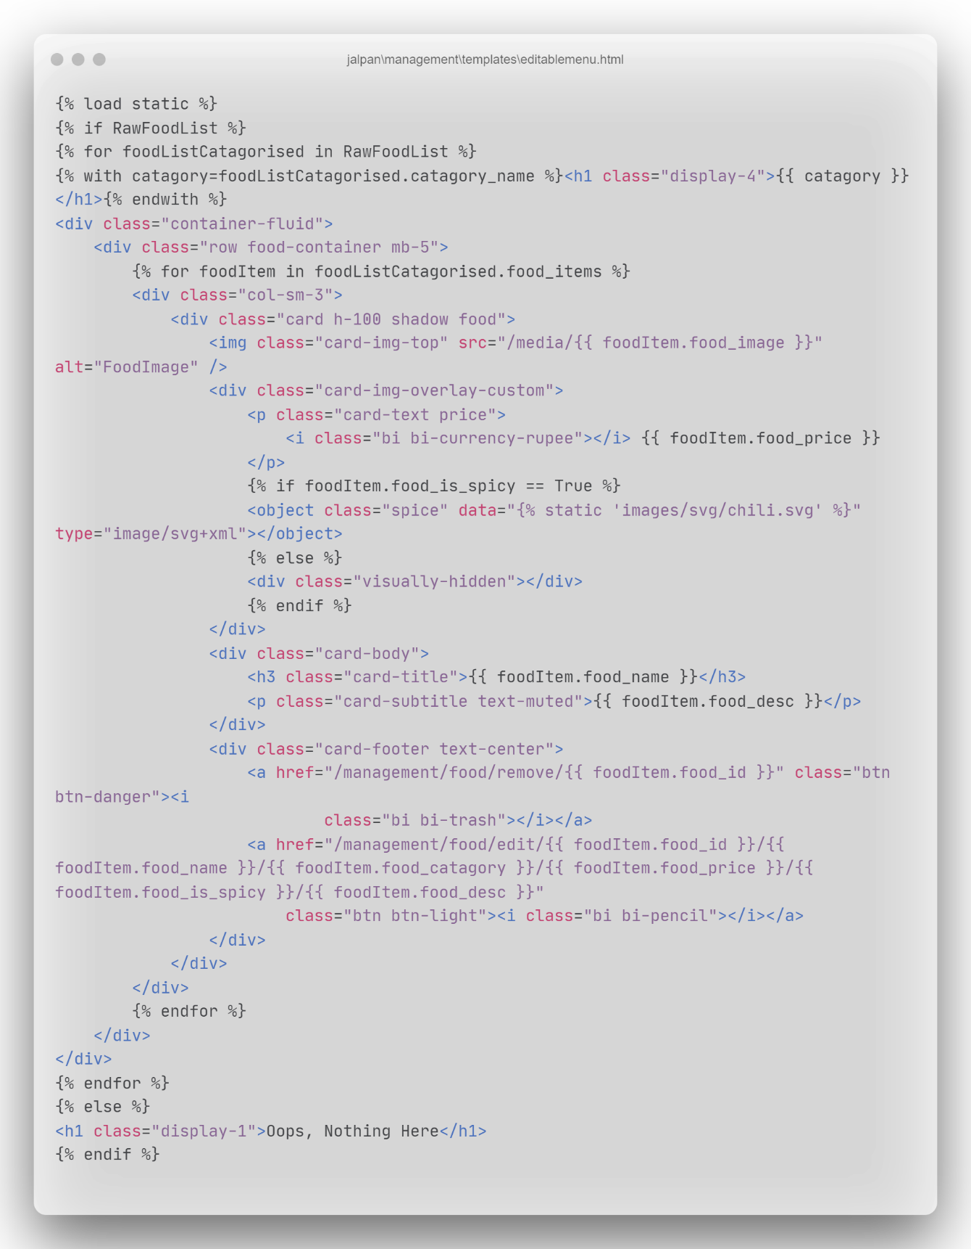

File: main.html

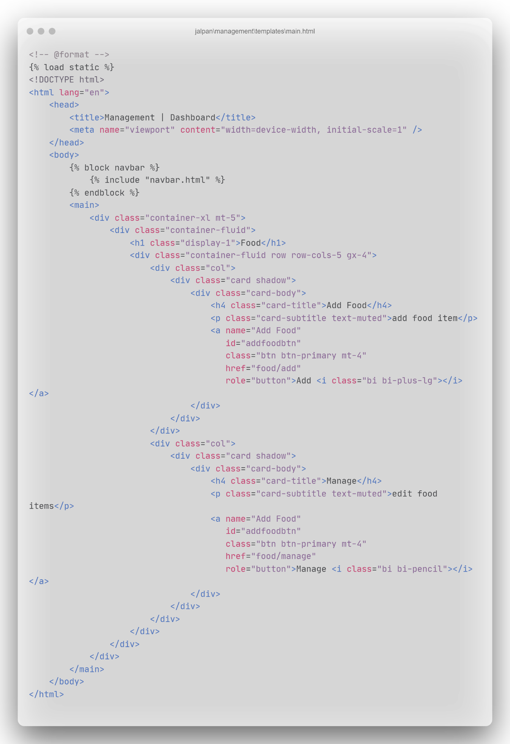

File: manageFood.html

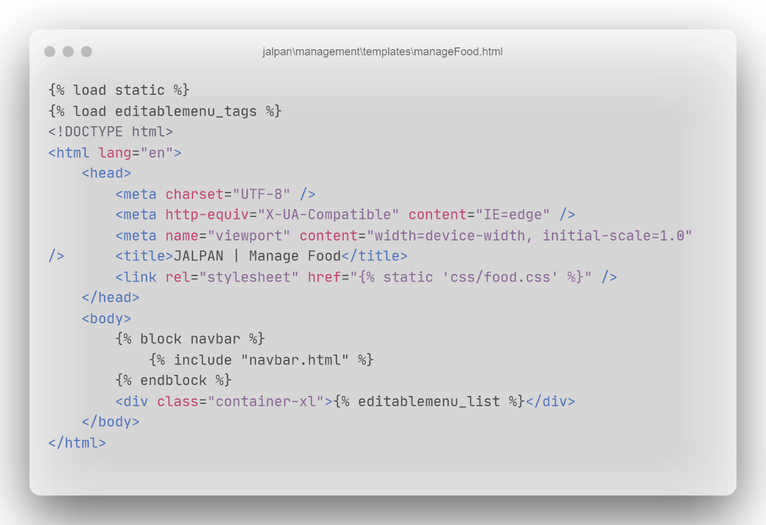

File: navbar.html

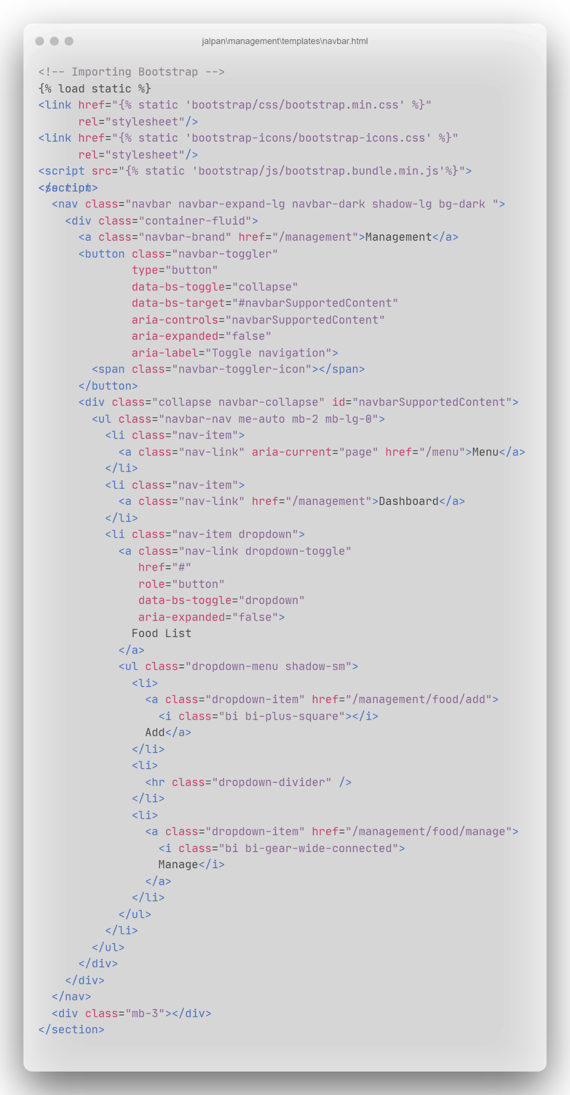



File: editablement_tags. py

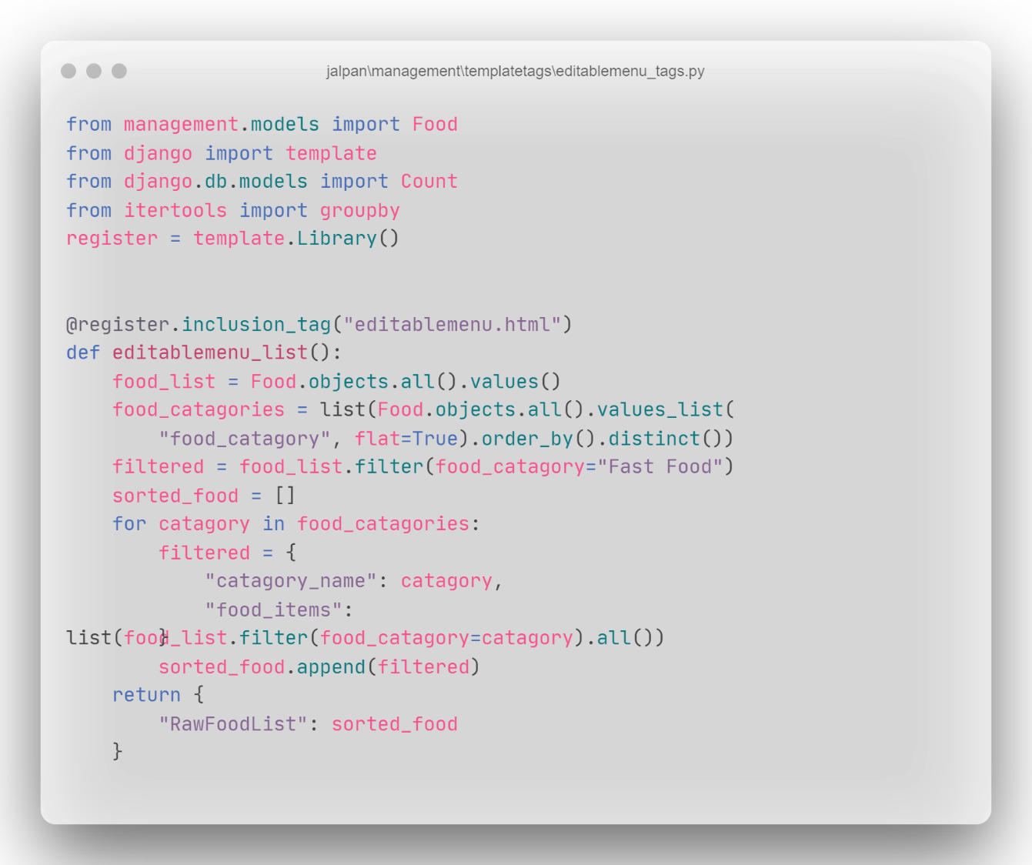

File: urls.py(management)

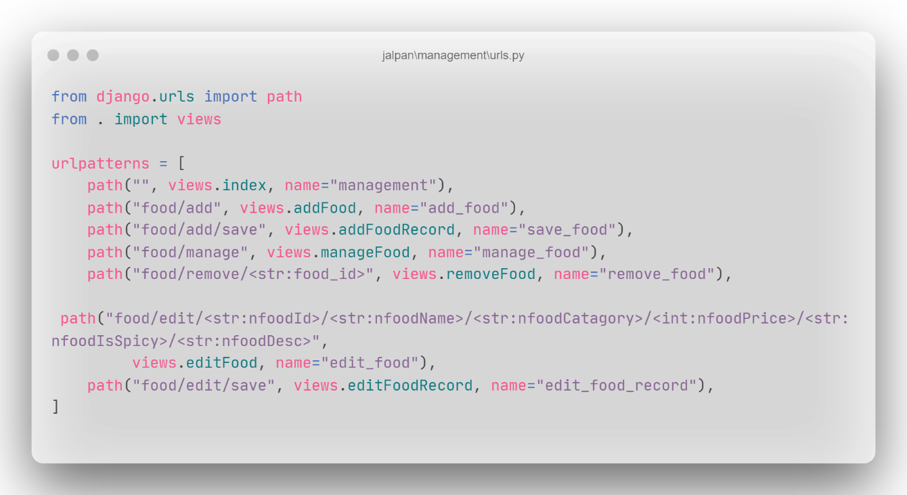

File: views.py(management)

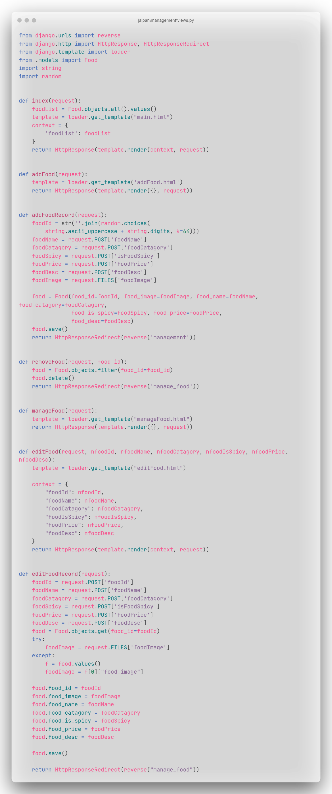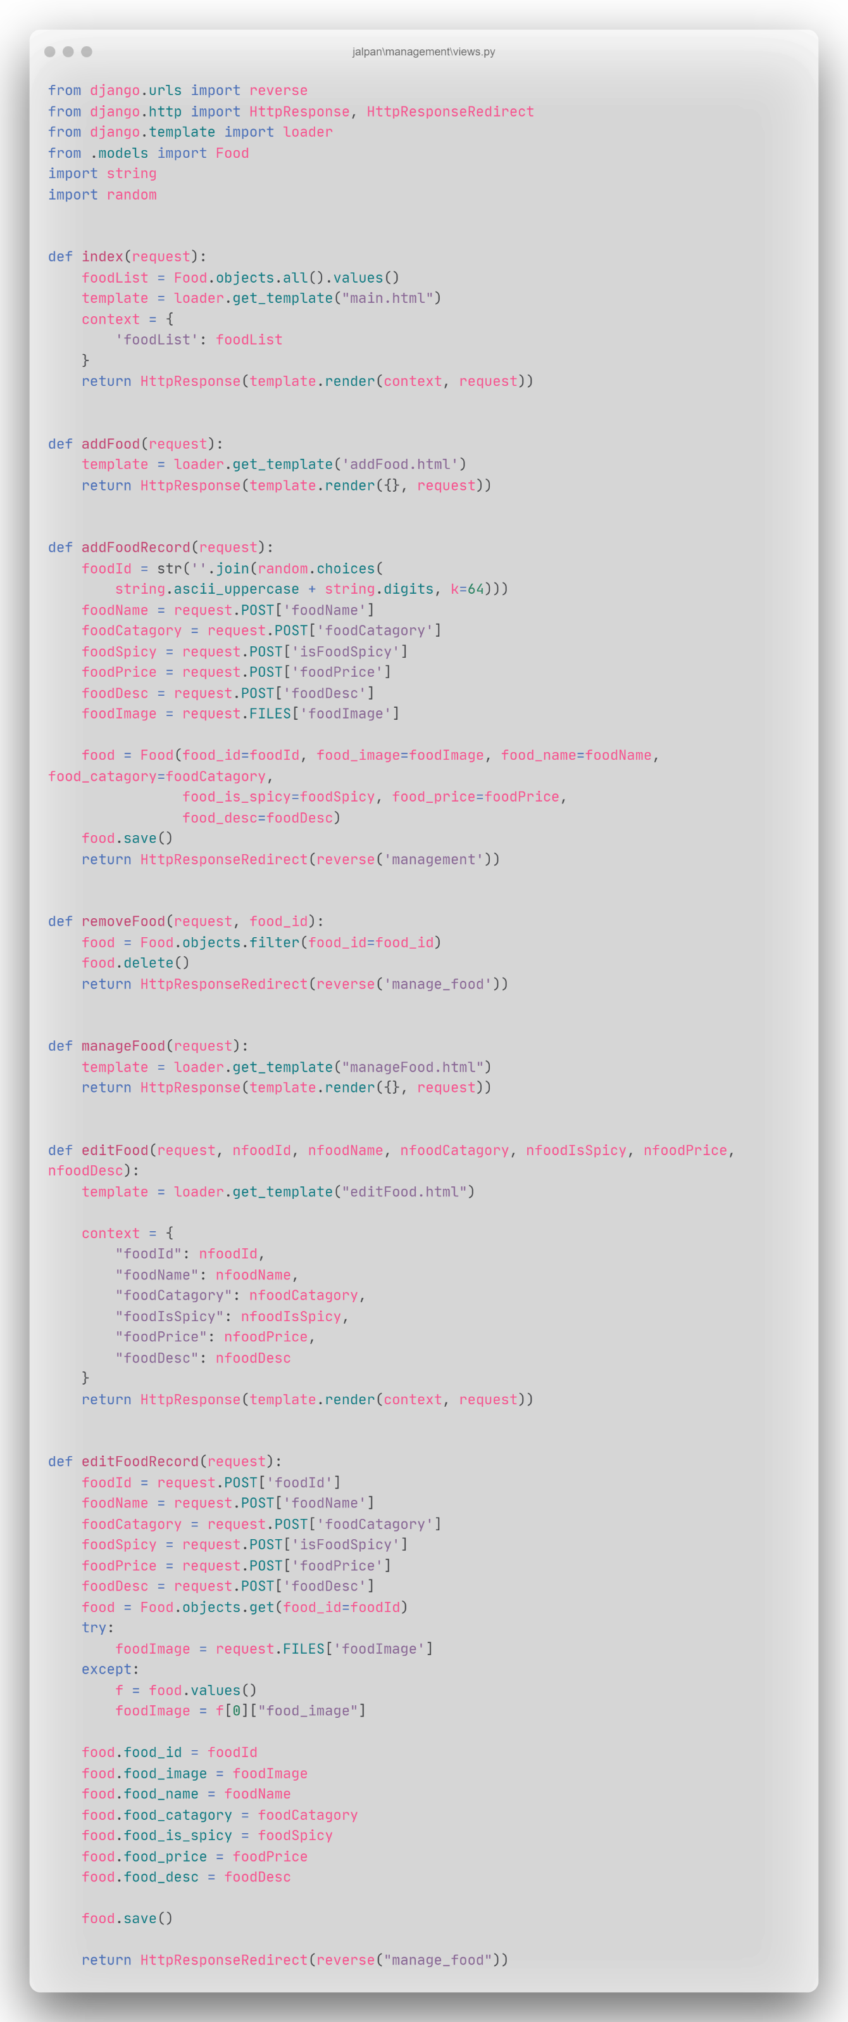



File: apps.py(order)

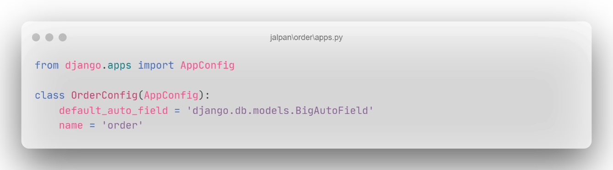

File: menu.html

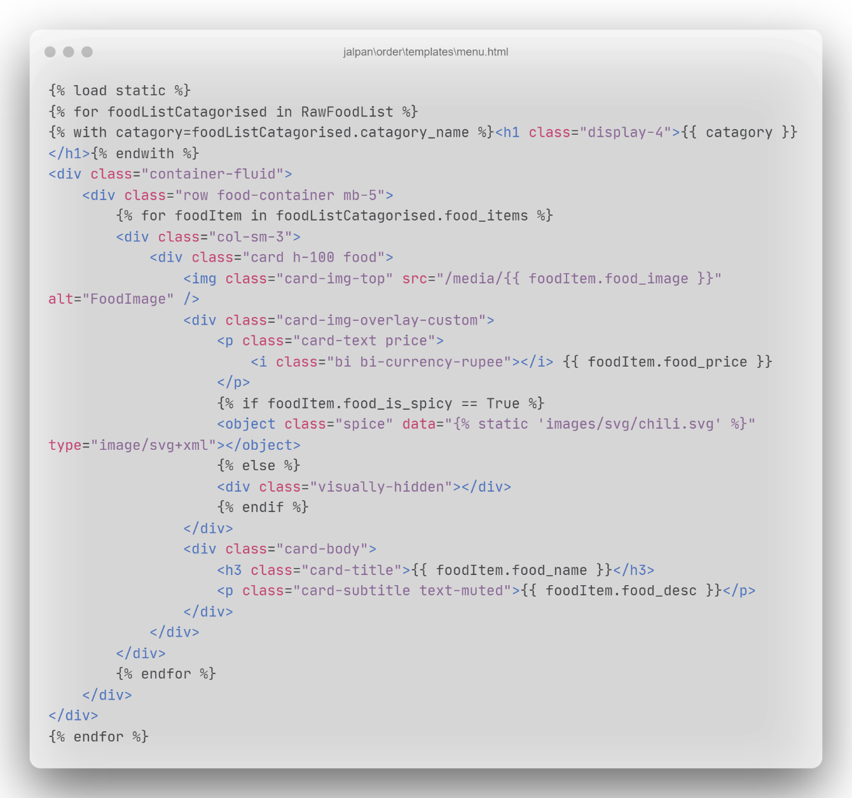

File: navbar_order.html

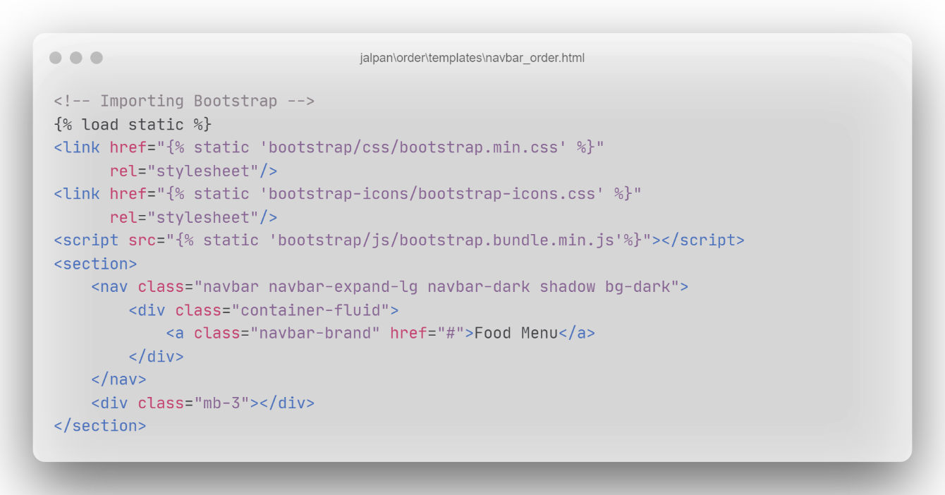

File: order.html

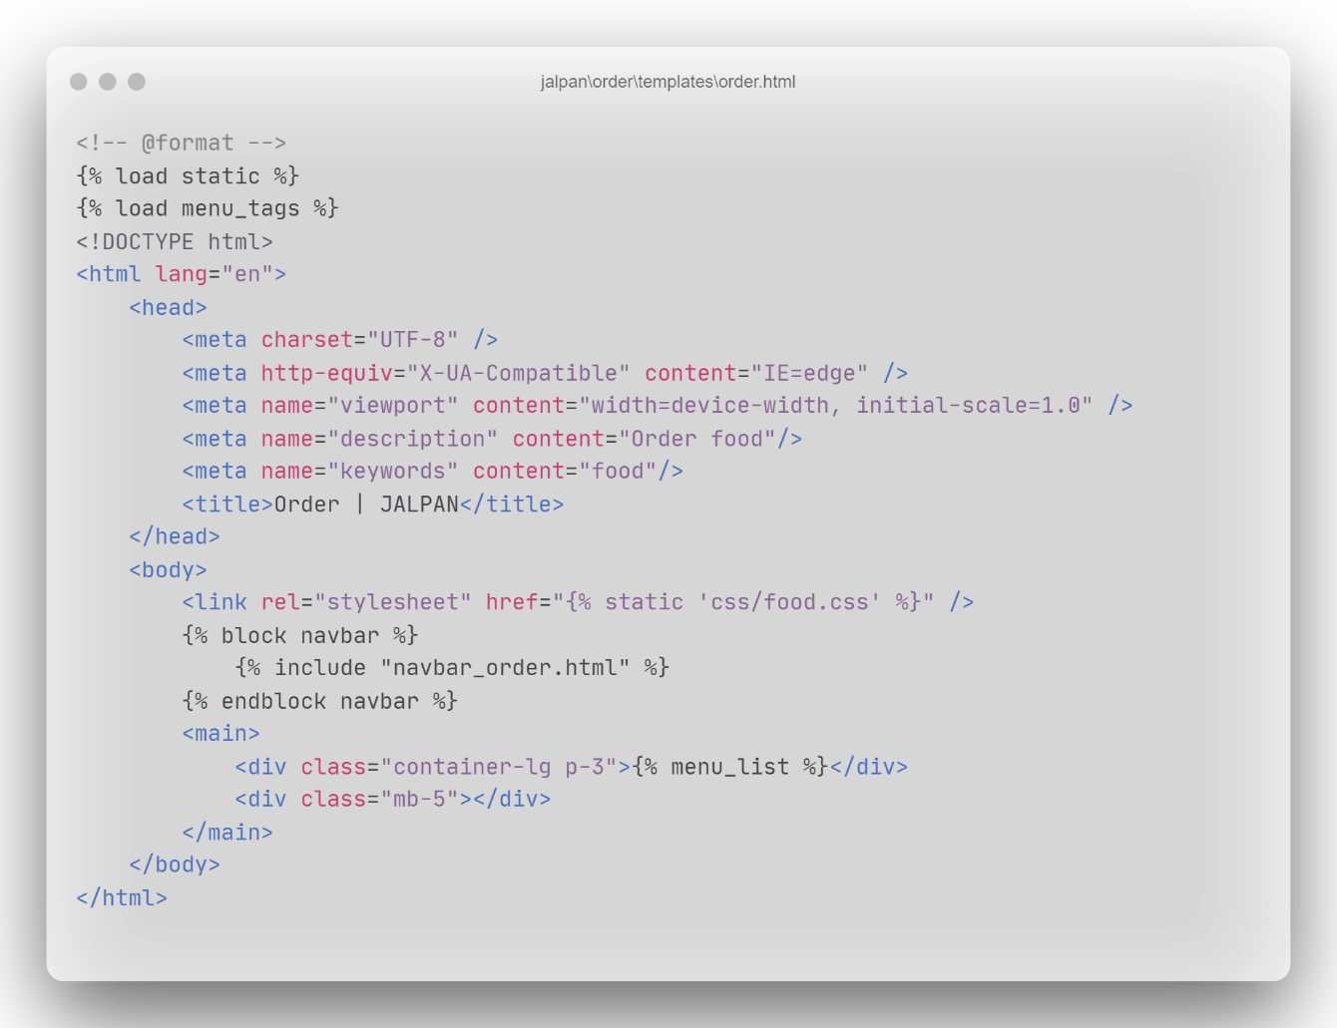

File: menu_tags.py

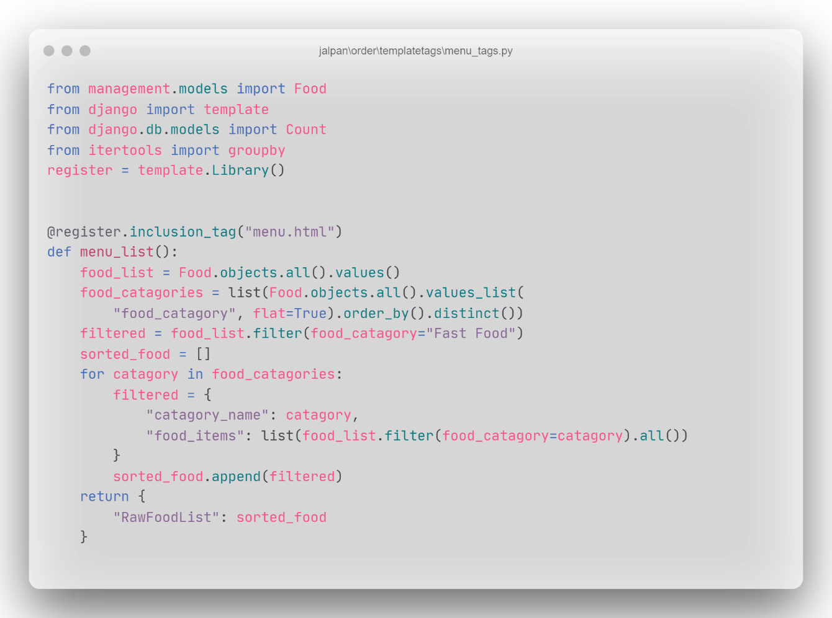

File: urls.py(order)

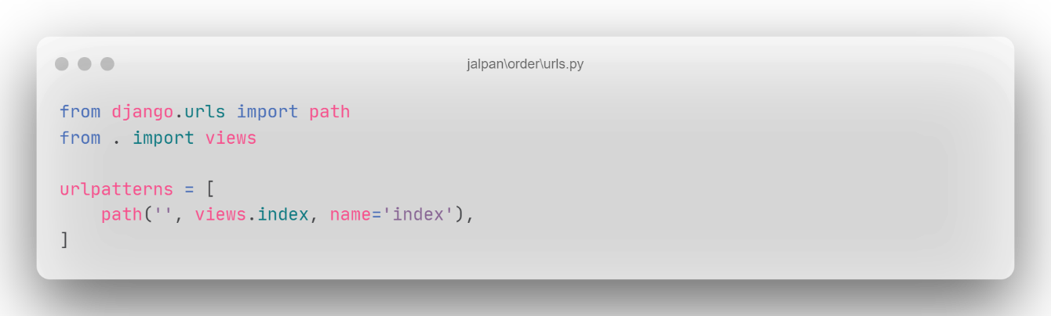

File: views.py(order)

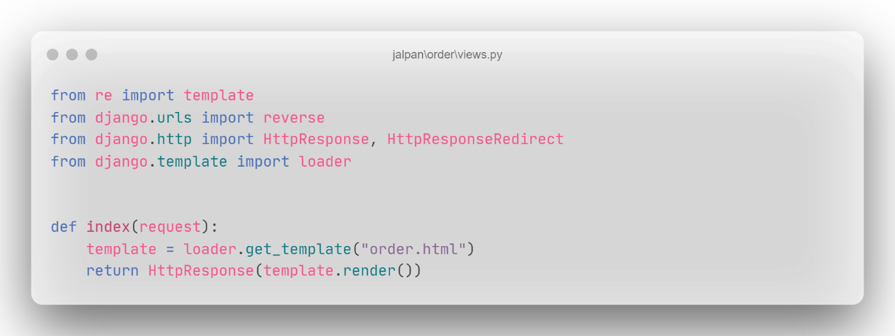

File: food.css

